Project Development Phase
Model Performance Test

Date | 30 September 2026
Team ID | MKU201Team66ab4dee00fc666a751b56cd7
Project Name | Script-Controlled ACL – Restrict Record Access Based on Field Value
Maximum Marks

Model Performance Testing:
Project team shall fill the following information in model performance testing template.
S.No. | Parameter | Values | Screenshot
 | Model Summary | ServiceNow script-controlled ACL setup for record-level security on the custom table Institution Details (u_institution_details) using Users, Roles and Read, Create, Write and Delete ACLs.  Note : Access is allowed only if the user’s role and the record’s Branch satisfy the ACL condition and script; otherwise it is denied. | 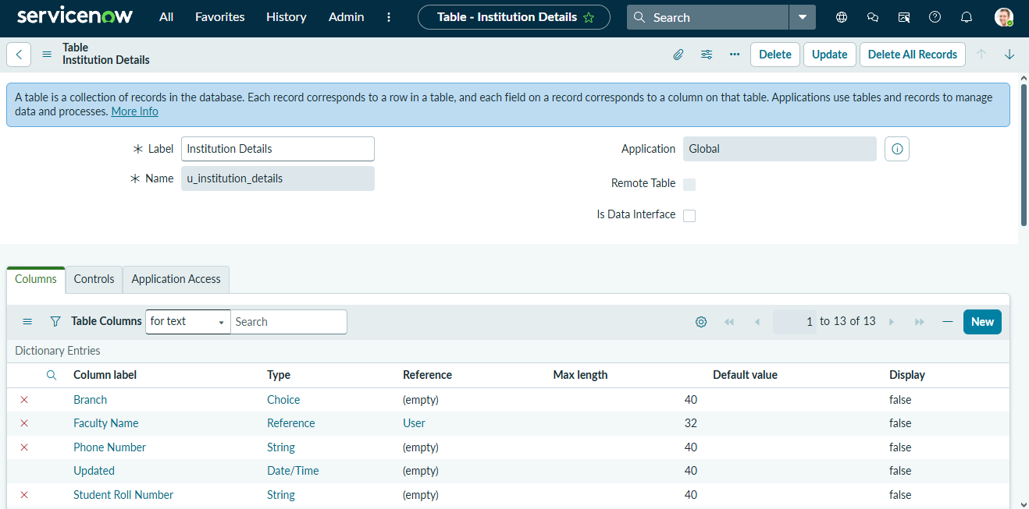
 | Accuracy | Training Accuracy - Not applicable (no trained model; rule-based ACL)  Validation Accuracy - Verified by impersonation: bb1 user sees only EEE records; Admin sees all; no-role user sees none | 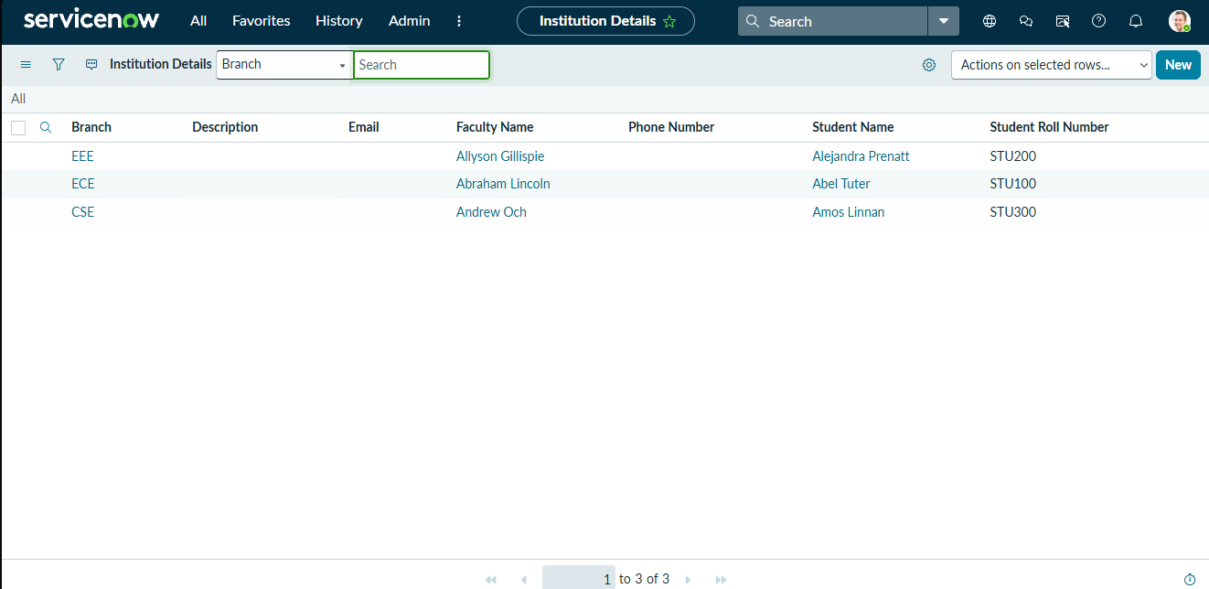
3. | Confidence Score (Only Yolo Projects) | Class Detected - Not applicable (not a YOLO project); rule-based: Role bb1 + Branch is EEE + Script.  Confidence Score - Not applicable; decision is Allow (admin / bb1) or Deny (others). | 